Unit 9 And 19 Personal Report
Contents page
Introduction | Task 3 Report - Prototype Implementation
Personal Report | Software Prototype Development
Team Role | Hardware Prototype Development
Project Management Methodology | Task 4 Report - Project Testing
What Went Wrong | Test Plan
What Went Well | Project Testing
Code Dumps and Comments | Review Of Prototype
Task 1 Report - Concept of Operations | Task 5 Report - Project Operation Review
Project Management Presentation | End Of Project Operational Review and Report
Examination Of Similar IOT Product | End Of Project Future Upscaling Plans
Feasibility Study And Alternative Feasibility Study | Conclusion
Task 2 Report - Project Design | Was The Project Successful
Implementation Plan | Is The Project Upscalable
Design Review | Effective Self-Management

Introduction
This document was made to help us explore how I have performed during the project and how I have helped to complete it and show the project was completed to a high standard in part because of my work.
I will be discussing many parts of the project including my role in the team, our project management methodology, as well as exploring some of the code I was responsible for and the breakdown of all of the relevant tasks that were completed and how I helped to complete them. Lastly I will discuss how I have effectively managed to myself and make recommendations for future improvement and upscaling of our project and prototype.

Personal Report
Team Role
At the start of the project, we had a team meeting to assign roles for the project and I was initially assigned the software lead developer role and the assistant team leader. however, the following week when we were finalizing team roles we agreed I would be team leader and head programmer as Archie S was not interested in the team lead role and I felt I was best able to do it.
My (Isaac T-S) responsibilities as Team Leader are Setting priorities, Defining product backlog, and Coordinates plans and tasks
My (Isaac T-S) responsibilities as Head Programmer are Assist in programming research, Responsible for programming the core of the game and updates, Big fixing, Initial code comments, and Testing code.
Overall, as team leader I was partially responsible for everything in the project and company helped on the second attempt of the document including a total e overhaul of several documents like the Project management presentation document.
Other members of my team’s roles.
When the team roles where first finalised Archie Stafford was assigned the roles of Scrum Master, Assistant Programmer, Assistant Hardware Developer, and Hardware Assistant Researcher. However later some of his roles where reassigned Archie did not end up being the Assistant Programmer as this role weas given to James W and instead of Assistant Hardware Developer he was the lead hardware developer as he was interested in the Pi.
When the team roles where first finalised Isaac Watkins Group Secretary (Documenter), Head Hardware Developer, Hardware Head Researcher, and Head General Researcher. However later one of his roles were reassigned that being Head Hardware Developer which was given to Archie.
When the team roles where first finalised James Workman Group Secretary (Documenter), Black Box Tester, Hardware Tester, and Assistant Researcher. However later most of his roles where reassigned he lost Black Box Tester, Hardware Tester, and become the Assistant Programmer, General Tester, as well as keeping his roles as Group Secretary and Assistant Researcher.
Over well the high number of role changes can appear to be a bad sign I think it is better to view it as us being flexible and responsive to the changing needs of the project and being mindful of our own skills.

Project Management Methodology
Project management methodologies are methodologies and project structures that help you to plan and mange your project there are meany of theses and we considered five main ones Agile, Waterfall, Scrum, Lean, and Kanban.
To decide upon which project management methodology to use we made a document called Project Management Presentation(deceased in depth hare).
This document explored, explained, analysed, and evaluated the details of each of the deferment project management methodologies to help us understand which was best suited for the project.
We analysed the Agile PMM and found it to be relatively good non-linear project management methodology, but we decided against using it as there are several PMM that are made form agile PMM and are simply better.
We analysed the Waterfall PMM but near immediately that it would be understood for our project as it is very linear in nature and our project would require us to back track repeatedly making Waterfall hard to utilize.
We analysed the Scrum PMM and found it to be very good for us as it is very focused on the feedback and communication which we felt would be optimum for our project considering we were not greatly skilled or experienced in what wee where doing and would be resilient on feedback to complete the project effectively. This is eventually what we choses to use.
We analysed the Lean PMM but quickly understood that this would not be fit for our project as it is too inflexible and is more focused on optimization than development this may however be an ideal chose for project upscaling in the future.
We analysed the Kanban PMM was a strong contender for the PMM that our project would use was its visual based task management will be very helpful for keeping us on track and understand what we need to do but we eventually decided that Scrum would be better though we may add in some elements form Kanban to help us complete the project.
Some of the key benefits of Scrum PMM that really helped us to where the regular Scrum meetings and sprints.
The Scrum meetings were held weakly and helped us to understand what team members where doing, what work need to be done to complete task, and helped to resolve any issues that came up.
The Sprints helped us break down the work into clear task that we need to do. This makes it much easier to assign tasks and to ensure the project is completed in a timely manner.
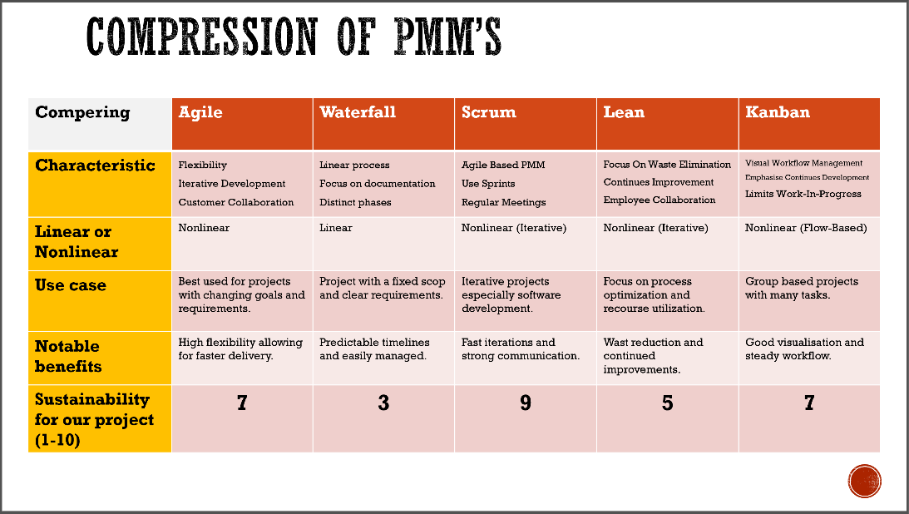
(Comparison table form the Project Management Presentation document)

What Went Wrong
Almost everything that went wrong in the project came from one simple thing, inexperience. Nobody in the team had worked on a project like this or on this scale before so we knew going into it that we would have to acquire a lot of skills during the project and potentially backtrack through the project to fix mistakes. This contributed to us using the Scrum PMM as it seemed ideal for backtracking in response to feedback and improved skills.
Issue One, Initial Poor Communication with Stakeholders: at the start of the project, we only realty had verbal communication and a large number of files containing information on what to do that took us time to work through. It took us a lot of time to fully understand the scoop of what we were working on as well as the fine details. As a result, we ended up wasting a lot of time at the beginning of the project on unnecessary work or work that ended up being insufficient for the needs of the project.
Thankfully we eventuality management to get on the same page as the stakeholders and got better information that helped us to complete the project but this end up with us doing a lot of back-tracking.
Issue Two, Hardware Mismanagement: we had meany issue with hardware nobody in the team had significant hardware experience and nobody understood how to use a PI. Additionally, we had issues with equipment going missing at the start of the project.
The lack of knowledge and skill with hardware was addressed with research and practises with the PI well the loss of equipment has solved by storing all of our necessary hardware in a box labelled as belonging to our team.
Issue Three, Further Details and Example of Team Members Skill Issues: as I have already said we all had a low skill level going into this project leading to issues with work not being done well.
The best example of this is from me as the Lead Software developer I has responsible for the development of the software, a game we planed to make in Python however nobody on the project myself include had experience in using Python I had to learn this as I worked on the prototype. This did work as I completed the functional prototype and there were few bugs but much of the code is amateurish and not to a high standard though is still functional.

What Went Well
Overall, I feel that the project could have done much worse, and we had a good flow of development for the project with progress continuously being made despite the lack of skills that our team possessed.
Successes One, Overall, Team Cohesion: the team worked very well together and got along well which helped us collaborate on tasks Archie S and Isaac W offt6emn worked other fort documentation and hardware work and Me (Isaac T-S) and James W worked tighter on the software of the project.
This helped us to complete the work quickly and to as high a standard as posable.
Successes Two, Early Success in the Software Prototype: I managed to get most of the hardware prototype finished at an early point in the project. This really helped us to be able to focus on the necessary documentation of the project as well as giving us plenty of time to get feedback and ensure the software of project was completed to a high standard.
This also helped us improve the software as I got feedback with lead me to implement other features to the game like multiple questions and email functionality.
Successes Three, Good Communication Between Team Members: we frequently communicate both on terms and ion regular scrum meetings this was helped by our initial plan to use the Scrum PMM as we knew that our cooperation would be the backbone of this project and an absolute necessity to its completion.
This helped us during meany parts of the project like the review where we all had to communicate to best understand the stats of the project and if it need additional work.

Code Dump and Comments
Introduction
This section will cover a section of the code around 100 lines long covering some of the main game loop. This is done to demonstrate my knowledge of the code and explain how some of it works.
All of the comments in the code below are mine this may be deferent from the comments in the main game code as I need to ensure that the comments hare was made by me. (Meaning comments made by other have been replaced.)
Commented Code

#main game loop
running = True # creates a variable called running and makes it equal to true.
clock = pygame.time.Clock() # creates a variable called clock that can be used to call Pygame.time.clock.

email_receiver = "" # default email address variable overwritten later

while running: # runs when running is true
current_time = pygame.time.get_ticks() # sets current time to the number of ticks past.

if game_state == PLAYING: # if the variable game stat equals PLAYING, this is set in an earlier part of the code and in response to player actions in the game.
play_music(PLAYING) # plays a music track for the PLAYING game state
elif game_state == QUESTION: # if the variable game stat equals QUESTION, this occurs if the player is in the same spot as an enemy.
play_music(QUESTION) # plays a music track for the QUESTION game state
elif game_state == GAME_OVER: # if the variable game stat equals GAME_OVER, this occurs if the lives variable equails zero.
play_music(GAME_OVER) # plays a music track for the GAME_OVER game state

#Quit code for ending the game
for event in pygame.event.get(): # code that fetches events
if event.type == pygame.QUIT: # if the event type is currently .QUIT then the following code runs.
running = False # sets running to false.

#movement code for player.
elif event.type == pygame.KEYDOWN: # if the event is keydown, means somebody presses a key.
if game_state == PLAYING: # following code players if the game state equals PLAYING
if event.key == pygame.K_UP: # if the key pressed is up
WH_hacker['direction'] = 3 # sets the player to moving up,
elif event.key == pygame.K_DOWN: # if the key pressed is down
WH_hacker['direction'] = 1 # sets the player to moving down,
elif event.key == pygame.K_LEFT: # if the key pressed is left
WH_hacker['direction'] = 2 # sets the player to moving left,
elif event.key == pygame.K_RIGHT: # if the key pressed is right
WH_hacker['direction'] = 0 # sets the player to moving right,

# code to handle question feature
if game_state == QUESTION: # code plays when the game state is QUESTION
if event.key == pygame.K_w: # if W key is pressed then the code runs
game_state = RESUME # Game state is set to RESUME, this resets parameters to allow the maze game to continue.
elif event.key == pygame.K_s: # if S key is pressed then the code runs
game_state = RESUME # Game state is set to RESUME, this resets parameters to allow the maze game to continue.
LIVES -=1 # # removes one form the current LIVES variable
elif event.key == pygame.K_a: # if A key is pressed then the code runs
game_state = RESUME # Game state is set to RESUME, this resets parameters to allow the maze game to continue.
LIVES -=1 # removes one form the current LIVES variable
elif event.key == pygame.K_d: # if D key is pressed then the code runs
game_state = RESUME # Game state is set to RESUME, this resets parameters to allow the maze game to continue.
LIVES -=1 # removes one form the current LIVES variable

if game_state == RESUME: # code plays when the game state is question
resume_game() # runs the resume game function, this resets parameters to allow the maze game to continue.

# game over/ email impute code
if game_state == GAME_OVER or GAME_WIN: # code plays when the game state is GAME OVER or GAME WIN
if event.key == pygame.K_BACKSPACE: # if player presses the backspace key, this allows deleting characters in email input
email_receiver = email_receiver[:-1] # removes the lasty character form the email_receiver variable.
elif event.key == pygame.K_RETURN: # Send email and restart game on pressing ENTER
send_email() # runs the send email function
reset_game() # runs the rest game function
elif event.key == pygame.K_SPACE: # Restart game without sending an email
reset_game() # runs the rest game function
else: # Add valid characters to email
char = event.unicode # sets the variable char to any correct Unicode impute
if char.isprintable(): # if the Char is valed
email_receiver += char # adds the Char variable to the email receiver variable

# player movement delay code
if game_state == PLAYING: # code plays when the game state is PLAYING
if current_time - last_WH_hacker_move_time > WH_hacker_move_delay: #runs if time has pasted
move_WH_hacker() # runs move player function
last_WH_hacker_move_time = current_time # resets time variable
# enemy movement delay code
if current_time - last_BH_move_time > BH_move_delay: #runs if time has pasted
for BH in BH_hackers: # for each individual black hat in black hats variable.
move_BH(BH) # moves enemy
last_BH_move_time = current_time # resets time

#maze code
screen.fill(GOLD) # background of maze
for y in range(GRID_HEIGHT): # sets maze walls vertical position
for x in range(GRID_WIDTH): # sets maze walls horizontal position
pygame.draw.rect(screen, BLACK, (x*CELL_SIZE, y*CELL_SIZE-550, CELL_SIZE, CELL_SIZE)) # sets black space for text to go on.
if grid1[y][x] == 1: # if grid has vale of one then code runs.
pygame.draw.rect(screen, GREEN, (x*CELL_SIZE, y*CELL_SIZE+50, CELL_SIZE, CELL_SIZE)) # makes maze walls green in designated spots.
elif grid1[y][x] == 0: # if gird equals zero then dotes / bits will appear.
pygame.draw.circle(screen, WHITE, (x*CELL_SIZE+CELL_SIZE//2, y*CELL_SIZE+CELL_SIZE//2+50), 3)# dotes, bits # spawns the white dots

draw_WH_hacker() # runs the display player function

for BH in BH_hackers: # for each black hat in black hats
draw_BH(BH) # runs the draw BH function for each black hat

score_text = font.render(f"Bits collected: {score}", True, WHITE) #display score and text in white
screen.blit(score_text,(SCREEN_WIDTH * 0.05, SCREEN_HEIGHT * 0.025)) # sets the size of the text and position
LIVES_text = font.render(f"Proxies: {LIVES}", True, WHITE) # displays the lives number and text
screen.blit(LIVES_text,(SCREEN_WIDTH * 0.75, SCREEN_HEIGHT * 0.025)) # sets the size and position of the life code

Task 1 Report - Concept of Operations
Project Management Presentation
Introduction
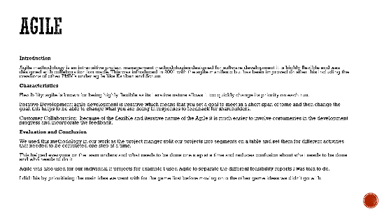
We made the Project Management Presentation to help us better understand the different project management methodologies that our project could posable be using. We considered five different Project management methodologies Agile, Waterfall, Scrum, Lean, and Kanban, event after considering our options we decided to go with the Scrum PMM with some elements of Kanban.
How I Helped and Details of the Document and How It Helped Complete the Project.
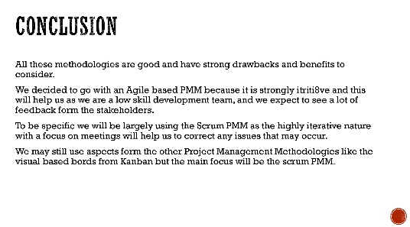
I did not do much for this on the first attempted but was responsible for all of the review changes which where substantial as the document was very sort and missing most criteria before my additions.
Before the updated I made most of the pages where very brief descriptions of the project management methodise, but I have expanded on it substantial to add multiple sections. Each PMM now has an Introduction, Characteristic, Evaluation and conclusion as shown in this example.
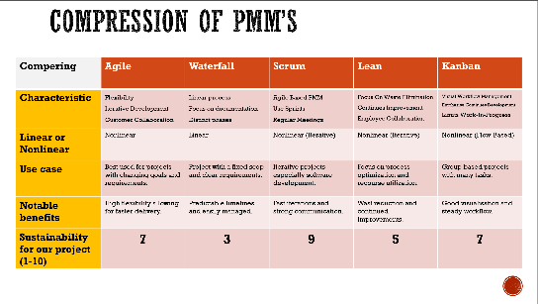
I also added a new section with a table to help compare the deferent PMM’S this helped people to quickly be able to asses some of the key details of the deferent characteristics of the PMMS and compare them to others.
Lasty, I helped expand on and add significant substances to the conclusion which explained which project management methodology we had gone with (scrum) and why we had chosen it.
There is more information about this document also in the sections Project Management Methodology and Design Review, Linked Here and in the Content Page.

Examination of Similar IOT Product.
Introduction
This document was to help each member of the team individually go through the past IoT projects in deferent sectors to help them understand where things tend to go wrong and what can help a project to succeed.
How I Helped
As this was done individually, we all had to make a document going over several deferent projects. I made a document exploring four different projects, NHS: National Program for IT (NPfIT), John Deere‘s: Intelligent agriculture systems (IAS), Cisco: Smart Campus Initiative (SCI), Bank of England: Real-Time Gross Settlement System (RTGS). Though originally, I only had three not having the RTGS include which has added after a review done as part of the Design Review.
Details Of the Document and How It Helped Complete the Project.
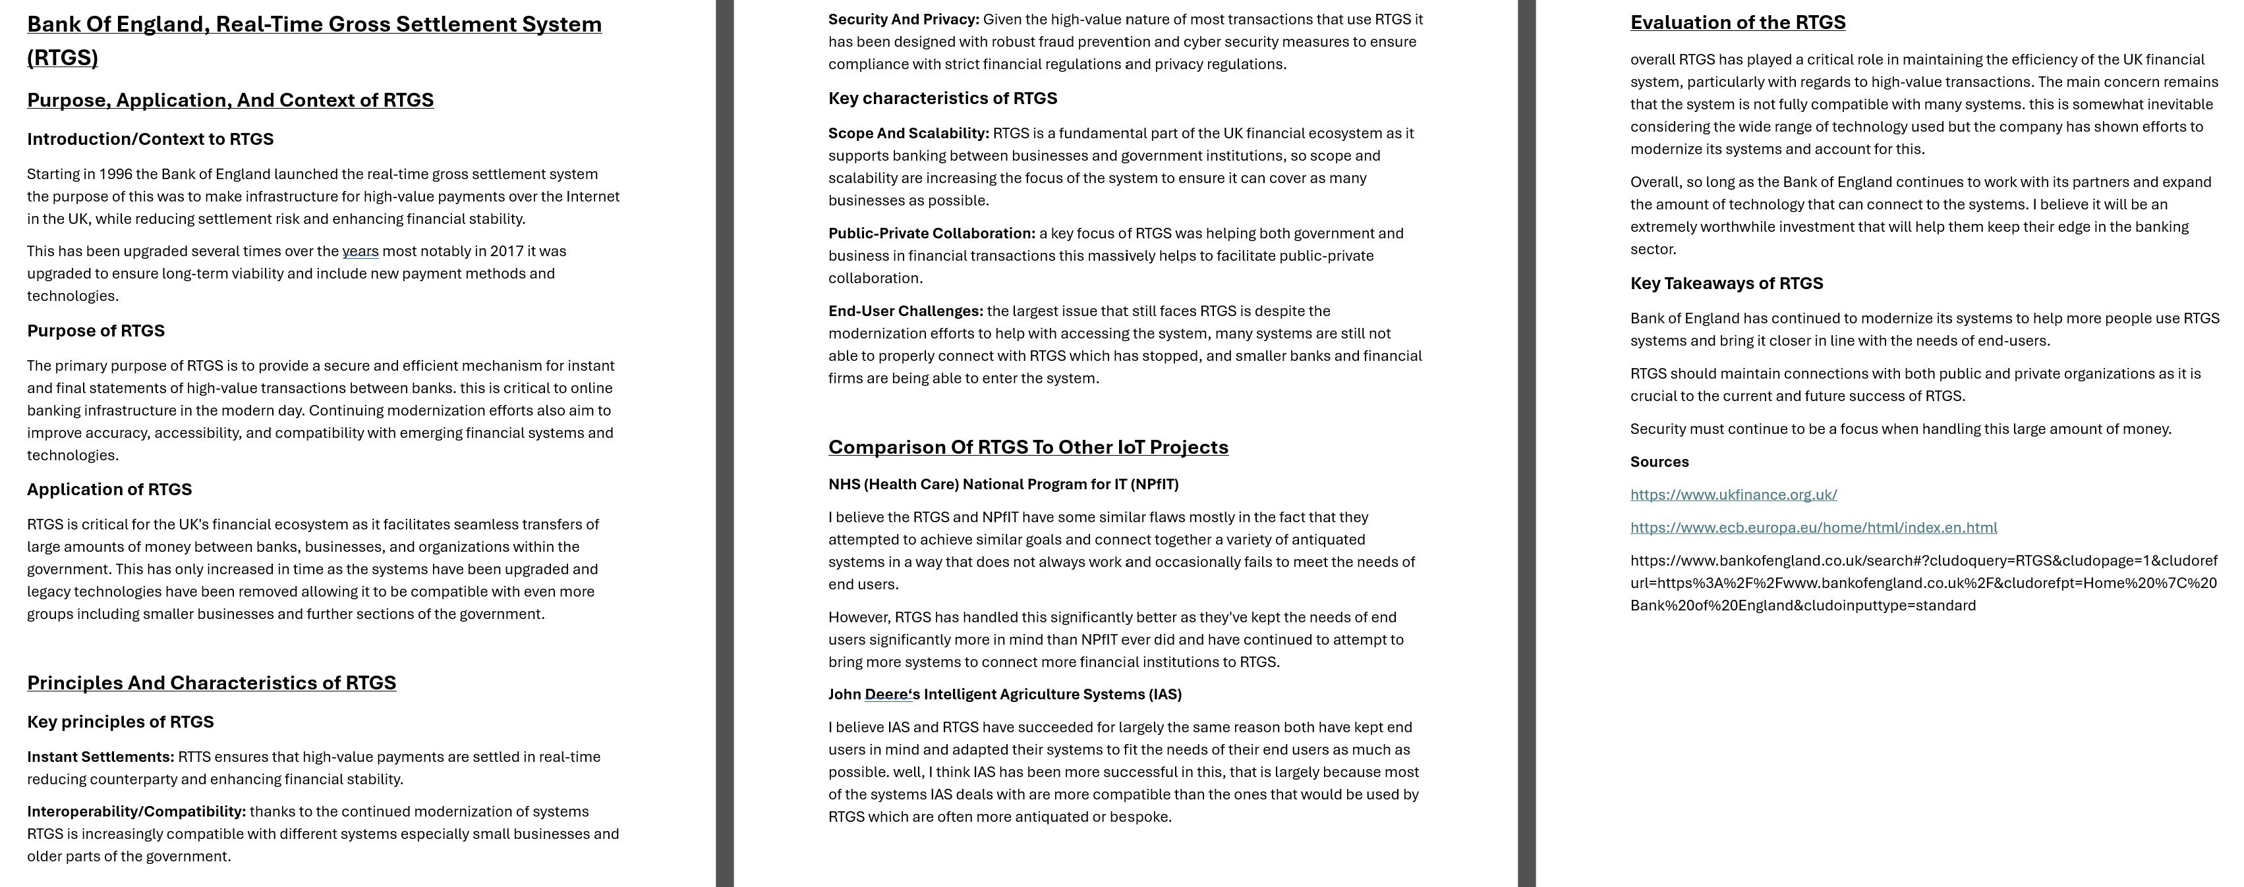
Above pictured is the Bank of England: Real-Time Gross Settlement System (RTGS), Section I added after the review. The other sections of the document have the same segments that I will discuss the purpose of now.
Purpose, Application, And Context of (Subject): this section has to explain and give a basic introduction to each of the projects we were analysing. And helped to establish basic understanding of the project.
Principles And Characteristics of (Subject): I made this section of the document to help explain the goals of the projects as well as what it was like in a practice senas by exploring the Principles and Characteristics. essentially a continuation of the introduction to establish general knowledge and of the project.
Comparison Of (Subject) To Other IoT Projects: this section compered the current project to at least two others to help establish what was different and what work for one project but may not have worked for other. This was critical to help understand what generally helps and what was just a flux in projects.
Evaluation of the (Subject): this was the most critical part of each subject as we determined if the project was successful or not and why it was successful or not. this was critical to help us understand what we need to learn from these projects for ours to be successful.
This project really illustrated for me the importance of communication between the team and our stakeholders as when I was evaluating each project, I continuously found a connection between good communication with end users and stakeholder and project success.

Feasibility Study and Alternative Feasibility Studies
Introduction
At the start of the project we had to establish several ideas for the project and came up with three deferent game ideas Hackmon, HACK-MAN, and Cyber Fighter (Tekken like game never formally named).
For each of these ideas we had to make a report detailing there feasibility the document covered several different key category like: Scope and Objectives, Project Management Plan, Risk Management, Resource Management, Technical Feasibility, Financial Feasibility, Operational Feasibility, IoT Concept and System Design, Hardware Setup, Software Development, Testing and Troubleshooting, Legal and Ethical Considerations, Environmental Feasibility, Documentation and Reporting, Final Conclusion. I will give some details of these below.
How I Helped
All the group assisted in the writing of the report myself include as I significantly help in the Financial Feasibility, Software Development, Testing and Troubleshooting, and Final Conclusion. As well as being responsible for an edit of the hole document to help it be better formatted.
Details Of the Document and How It Helped Complete the Project.
Scope and Objectives: this was to determent the goals of the project and view scope creep in the project by establishing what we wanted to do at the start.
Project Management Plan: this was the initial detailing of how we would use the PMM and contains the initial plan for how we would utilize scrum though this is not totally accurate to how we ended up using it.
Risk Management: this section was done to establish the risks we expected to face and to how we plan to manage and counter them.
Resource Management: this was a simple part of the document that went over how we would manage our hardware and other physical resources.
Technical Feasibility: this went over some of the technical challenges we expected to face and how we planned to manage them if we believe we could.
Financial Feasibility: this is a section I had a strong hand in and was largely adapted from the budget plan I also helped to make at the beginning of the project. This was vital for our understanding of how much each perspective project might cost.
Operational Feasibility: this referred to how feasible the management of each project was and was largely identical between the deferent ideas as they all had similar goals and methods.
IoT Concept and System Design: this section covered basic plans of how we will integrate IOT and how we will go about making the hardware and software needed for the project.
Hardware Setup: this goes into detail about how we planned to make the hardware record for the project and what we planed to use. This helped the project by establishing what we need to get and how it would go together.
Software Development: software development was one I detail with some of this ended up being outdated as we decided to use Python over C# shortly after the creation of the document but most of the other details are still account and this really help us to understand what we would be doing to develop the software side of the prototype.
Testing and Troubleshooting: this covered the beginning of how we planned to test the project and ensure that it is fully functional and was a key part in establishing how we will do testing.
Legal and Ethical Considerations: this was where we went into a few deferent legal and ethical concerns and helped us to establish out what our key legal concerns would be.
Environmental Feasibility: this explored what effects our program would have on the environment, and we quickly relived that due to the size of the project we would not have to worry about this for any of them.
Documentation and Reporting: this covered the basics of how we planned to cover documentation and reporting throughout the project. This help us set up our early standards for documentation but didn’t really cover the extent of what we would be doing.
Final Conclusion: this section was the most important as it determined for each of the ideas if we believed it would be feasible for the HackMon and Cyber Fighter game we found issues with them that would have made them non feasible, but the Hack-Man idea seamed variable. (Hack-Man conciliation showed Below).
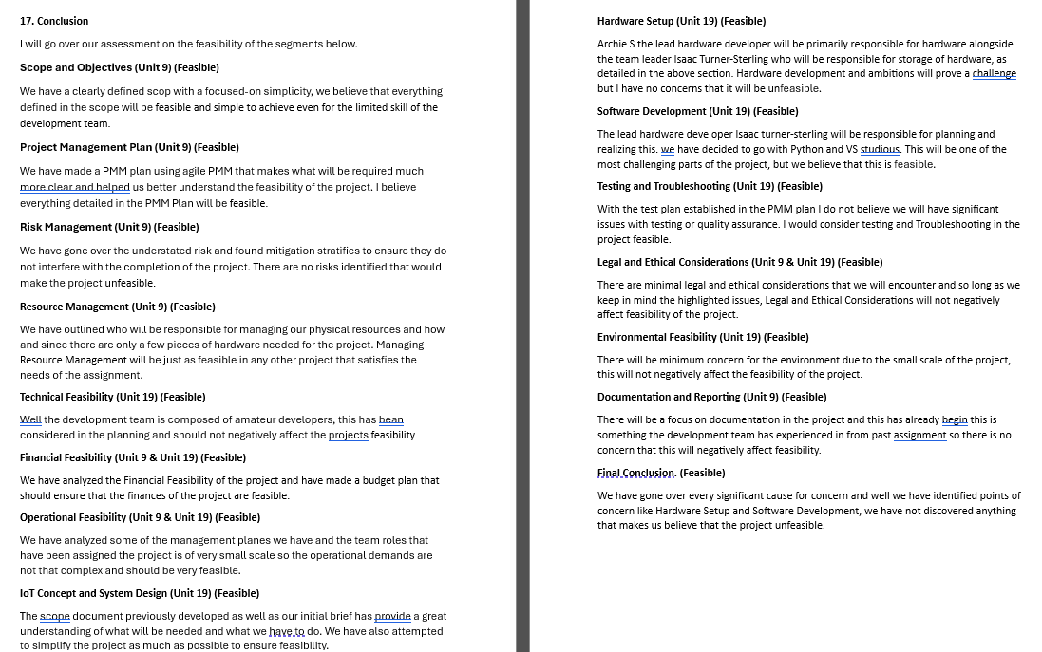
Overall, we covered a lot of ground when we made this and didn’t go into a lot of detail for each witch stopped this from being overly relevant to the latter part of the project but it did help us to establish much of what we need to do and importantly we need to do this to ensure that our idea would work.
These documents were also reviewed as part the design review, but we did not need to changed much of it as we had already largely gone past the need of it and had already done an edit of it after it was first completed and ensure ed that it meet the necessary criteria then.

Task 2 Report - Project Design
Implementation Plan
Introduction
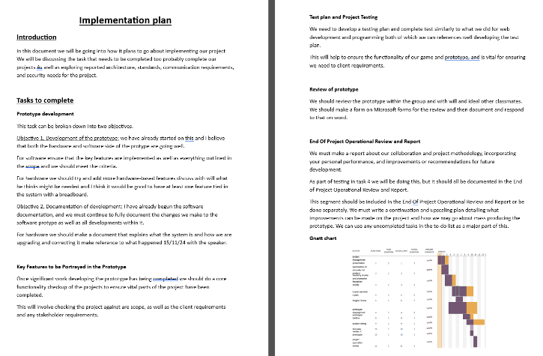
The implementation plan was to help us plan how we would actualize the ideas we had into an actual functioning prototype. We did this by breaking down what we need to do into set tasks and with designated times to complete via the Gnatt chart, as well as planning the Budget, Communication Standards, Security Standards, And Architecture Standards.
How I Helped
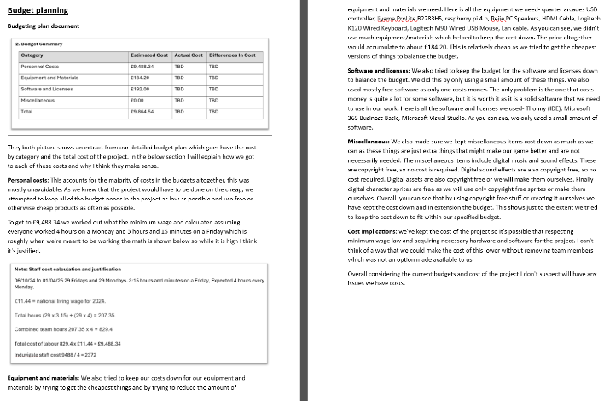
I helped to complete this at a verity of points. For the first draft of the document, I mostly worked on the budget part of the document where I helped to prepare a separate document called the budgeted plan where I broke down all expected costs for the project as well as planning for extra cost, which we then incorporated into the implementation plan.
Most of what I did for this document came with the design review I was responsible for I caried out the review and edited the document massively overhaul and improved the document including adding the critical tasks to complete document to explain exactly what we would be doing.
Details Of the Document and How It Helped Complete the Project.
The top of the document is the tasks to complete document in which I break down everything we need to complete to finalize the projects development, like prototype development, key features check, testes plan and testing, review of prototype and end of project personal report(this).
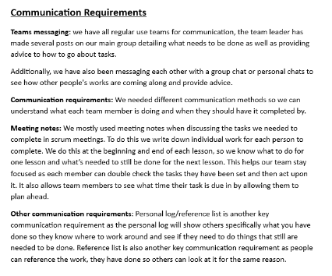
The tasks to complete document didn’t massively detail what need to be done as we knew there would enviably be a lot of changes as the implementations of our plans contained especially after the initial completion of the software, so we felt that it was important to keep the project and plans flexible to adapt to changes. Simler to our choice to use the scrum PMM.
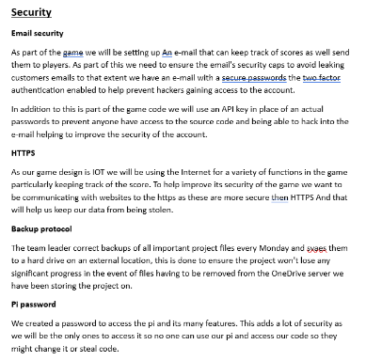
The budget plan section was made from a separate budget plan document I made and was also shown in the document in the form of a screenshot. This section of the document was useful to help ensure that we understood the exact cost of the project and how much the wagers the team would cost, though the team is not actually being pied we just had to calculate it for the documentation of the project’s sacks.
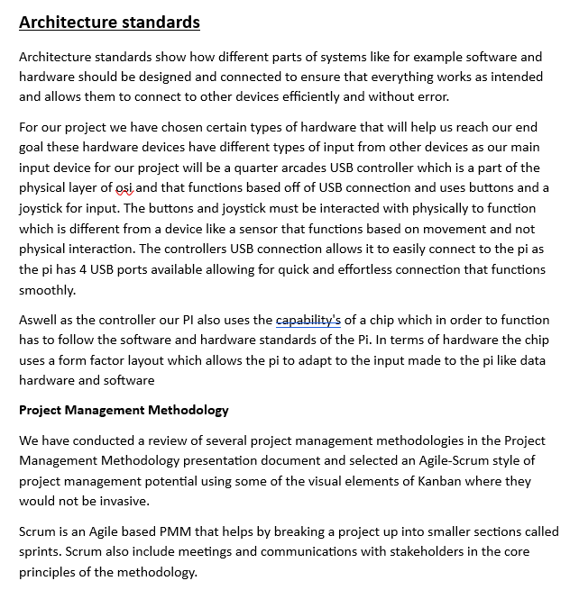
The communication requirements was an important section of the document that helped to dictate how we intended to comminate with each other. In this section we described how we intend to use teams for most direct communication as well as setting standers for being professional and making sure that meeting notes are taking during scrum meetings. Additionally, we were all encouraged to keep personal logs detailing what we were doing day to day to help us make our personal reports at the end of the projects.
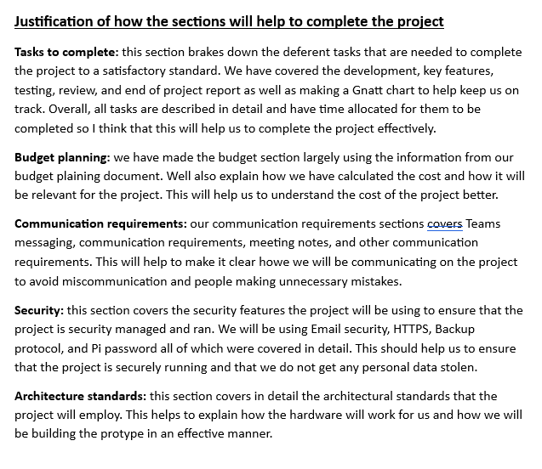
The security standers section was made to cover some of how we planed to ensure that the project would be keep safe and how we would avoid personal data loss. We covered our Passwords, PI Security, Email Security, HTTPS, and Backup Protocol. This helped to establish the standards we needed to use to ensure we did not loss personal data.
The Architecture standards covered how we would go about ensuring that the hardware has properly made and safely managed. This was largely handled by our hardware lead Archie S and covered a lot about how our PI would work.
Finaly the justification section was just made to help explain how the document would help us complete the project similar to the details hare.

Design Review
Introduction
The design review was done to cover all of the design and implementation planning documents so that we made and ensure that it meet the needs of the project and the criteria set out by the stakeholders of the project.
The document covers Project Management Presentation, Examination of Similar IOT Product, Feasibility Study and Alternative Feasibility Studies, Implementation Plan. To ensure that they met the standards outlined in the brief and specification.
How I Helped
As team leader I oversaw the reviews and prepared the review forms on Microsoft Forms, and I did most of the editing in responses to the reviews.
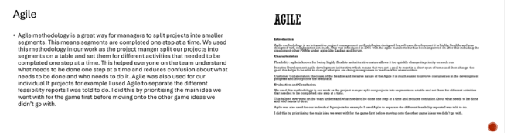
The first document we reviewed was the Project Management Presentation this document was very insufficient, so we decided that it need a massive overhaul, and I was responsible for completing it. I had to add a section compering the project management methodologies, as well as massively expanding the descriptions of the Project Management Methodologies as shown in the example and expanding the conclusion.
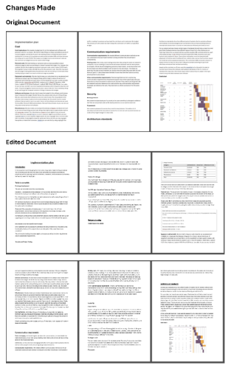
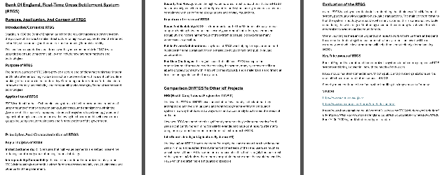
The second document was the Examination of Similar IOT Products, which was a bit deferent as this was individual work so well, we had one review form, and it only had one slot for it in the document each team member was responsible for their document and if they felt they need to improve upon it. I did decided to expand on my document, adding a section on the bank of England but to my knowledge the others did not feel the need to change their documents.
The third document was the Feasibility Report which I oversaw the review for but we had already gone over this shortly after its completion, so we ended up not adding anything else to it as It did not seem necessary.
The fourth document was the Implementation Plan this document was decent but need to be expanded and have the task section added which I helped to add to the document as well as making other edits through the document. Most notably in the budgeting section and security standards.
Details Of the Document and How It Helped Complete the Project.
This was an essential part of ensuring that our project planning and design was sufficient for the standards of the stakeholders and will help us to measure we are fully prepared for the project and needs of the end-users.
If it were not for is completing this document I would not have made the additions to the three documents that we edited and they would have been left insufficient for the needs of the project and potentially lead to further issues later in the project.
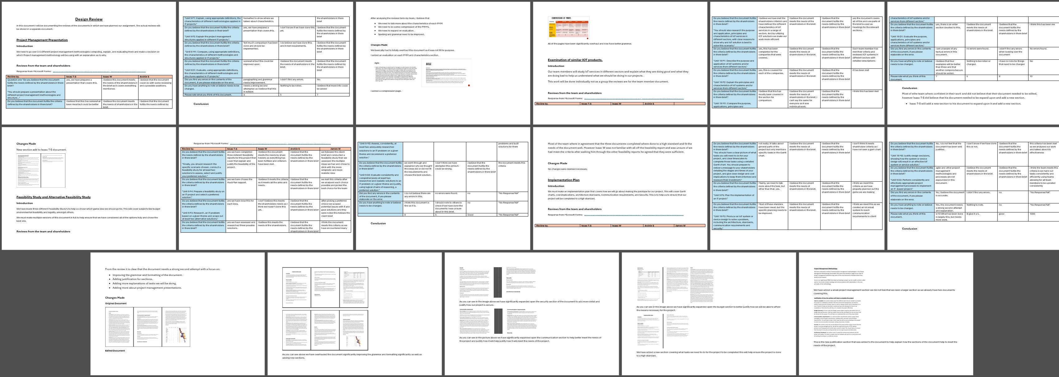

Task 3 Report - Prototype Implementation
Software Prototype Development
Introduction
This refers to the development of the software half of the prototype. I was the software development lead so this was primarily my responsibility, and I did most of the development of the game though some of the other work was done by others primary James W how was my software development assistant.
How I Helped
I was responsible for the majority of the programming and documentation for the project which was done in the software development log document to help us keep track of changes to the software and to avoid future mistakes
I used Thonny as the primary Intgrated development environment as well as Microsoft visual studio to help me with some of the white space formatting need to make python work. Additionally, we were using the Python programming language.
I started the programming of the game following a guide to make a pacman like game in Python which helped to make the core maze play functions and have a working player characters and enemies.
From there I changed many of the assets of the game to look more like the aesthetics we wanted for the game (hackers on a mother bored).
The next feature I added was the question’s function, after this was added when the player encountered an enemy instead of dying, they have to answer a question and if they get it right the game resume and if there wrong then the player losses a life.
I also added game over screens for dying and winning the game which was needed for ethe core functionality of the game and to give it an end state.
I added three deferent music tracks to the game that plays depending on the game states music. This was surprisingly difficult to add and took a while to get right but was an essential part of the project.
I then added a few smaller features like, multiple questions, soft-lock prevention, and multiple live. Each helped to improve the overall functionality of the game in small was and most where easy to add.
Lastly and most impotently I added the IoT feature after the end of every round wither you die or when you have the option to send an email to your account to create a record of the score you got that round this is possible to do after ever round is completed and the email is saved after entering it the first game unless the game is closed for the email is edited.
After this the game was largely consider complete and only miner additions and fixes where made.
Details Of the Document and How It Helped Complete the Project.
This was essentially half of what we need to complete. the goal of the project was a functional game protype with both hardware and software obviously needs software.
This also helped to cover the IoT integration part of the project, we have added in and email functionality in the main game loop at the end of each round you have the option to send an email that contains the score you got to any email your choices to impute.
This also helped to cover the security requirements of the game, we had a verity of security features in the code of the game and how it functioned that helped ensure that it is secure.
We had the password of our email encrypted in the game code to prevent people from being able to access the email if they had a version of the code, which was important to help us ensure that the personal data in the email account would not be lacked accidently.
Obviously when transmitting data online we used the HTTPS practical as this is what the email company’s website used this will help to prevent data being stolen in the event of an man in the middle attack.
We also keep an offline backup of all the files for the document this helped us to ensure that the project was secure and would not be lost in the event of the clouded based files being lost.
The development of the project could have been better but considering that nobody on the team made made a game in python before did massively limit the capability of our team. Overall, I fell we did a good job and that we did the best we could with what we had on hand.
I would strongly encourage you to check the Commented Code Dump linked here as to goes into some of the functioning of the code. Additional anybody reading this document should also have access to the latest version of the software and I would strongly recommend that you play it for yourself to understand what the game is really like.
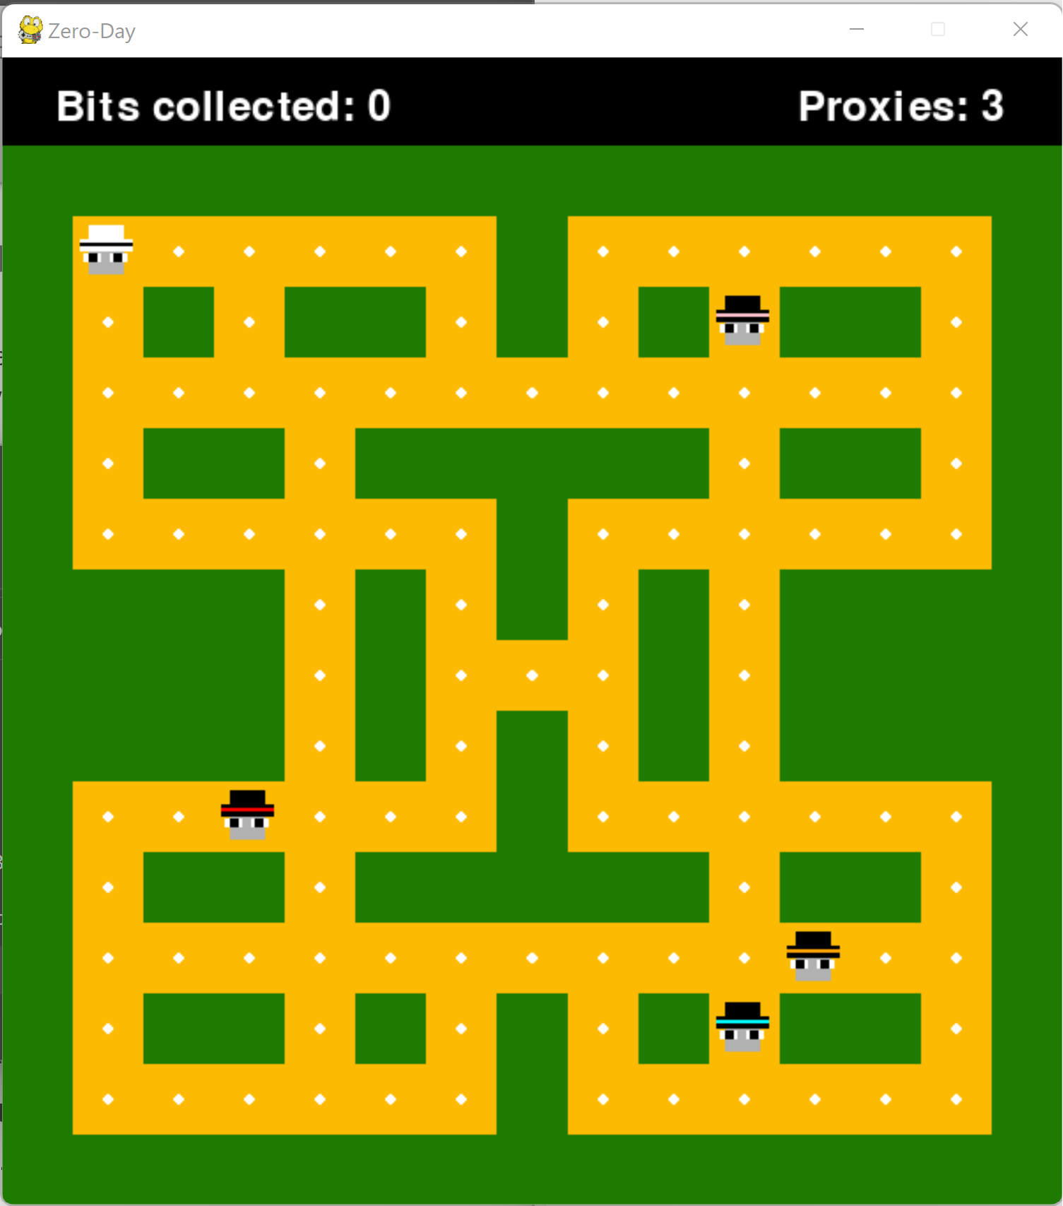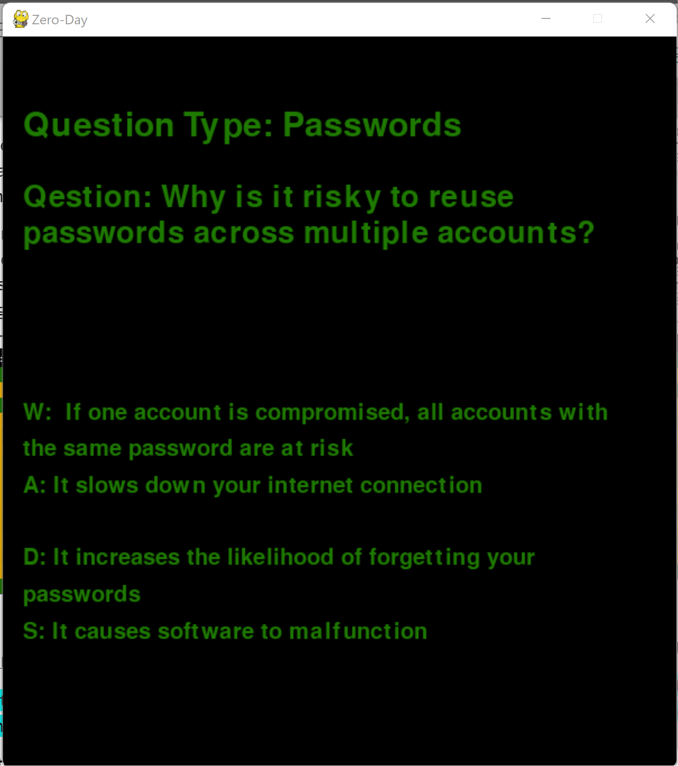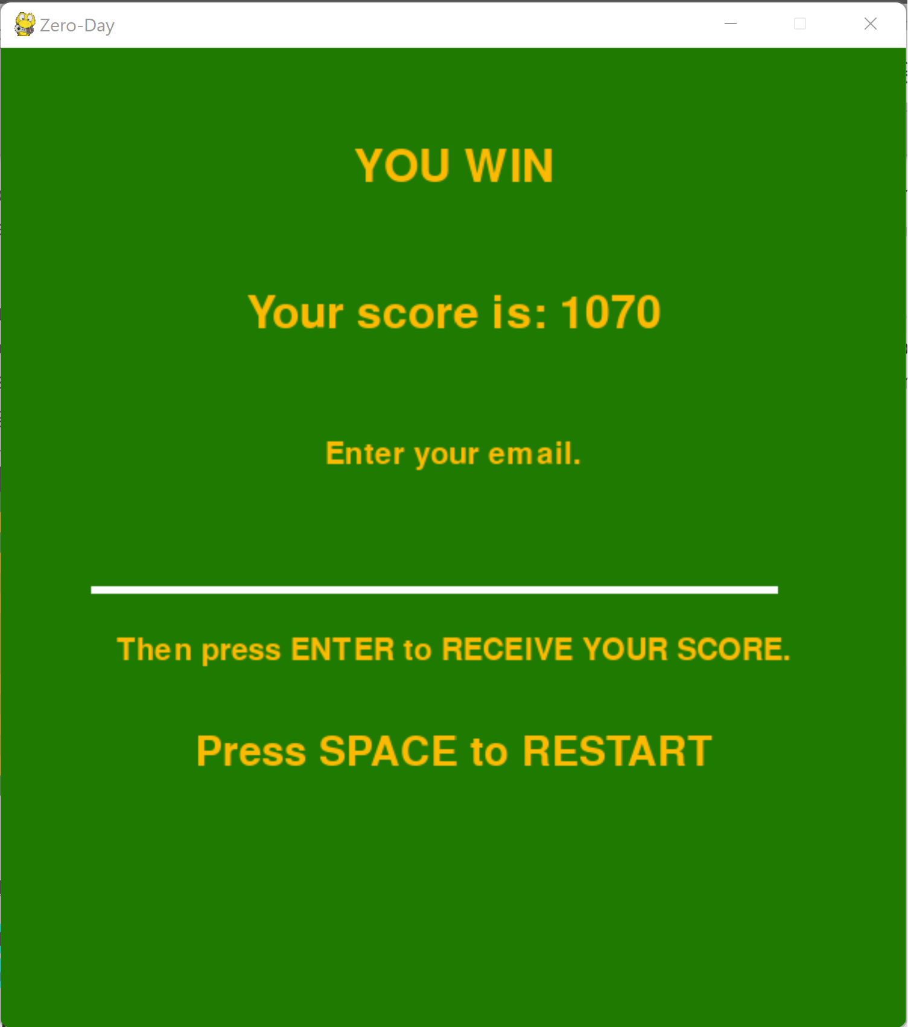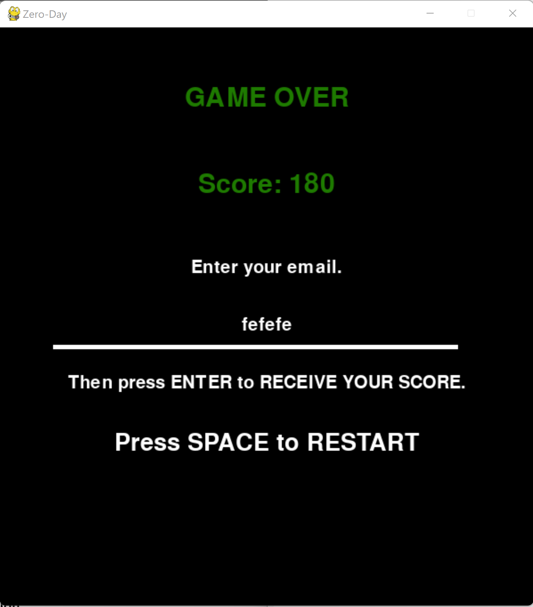

Hardware Prototype Development
Introduction
We were responsible for setting up the hardware for the project. We did not have massive amounts of money so this was an assembly of the shelf pats not fully manufacturing of a new system. The most important computer was the raspberry pi 4 which was responsible for running the code of the game.
How I Helped
I was the software lead for the project and Archie S was the Hardware lead so I did not end up working on the hardware protype much but I will explain what I did do here.
I helped to test the software on the Pi, as the game was going to run on the pi it was important that we tested it on the hardware and I was responsible for this. Testing section linked here.
I helped Archie S to set up the accounts for the PI and manage the security on the devices. We ensured that the pi had a strong password to keep the data stored in it secure.
The speakers used in the project where originally mine, I used to use theses for my home computer but did not need them so I bought it in for the term to use to help keep the cost of the prototype down.
I assisted Archie in budgeting the prototype and doing some of the early research.

Details Of the prototype and How It Helped Complete the Project.
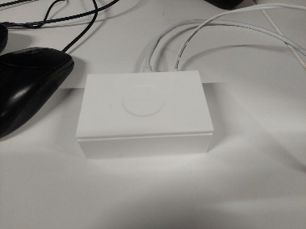
I would strongly recommend that you check out the task 3 demonstration video as this goes more into detail about the workings of the hardware protype as well as showing it in action.
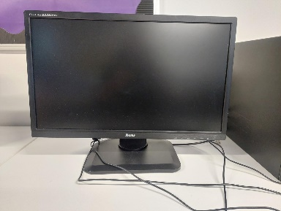
Raspberry Pi 4: the Pi 4 is a small computer and is capable of running programmes like ours very well at a low prices and avoids us wasting resources and power. This is crucial to us to be able to run the code of the protype and acts as the computer.
Prolite B2283HS: this is the monitor of the prototype that we will us to be able to see the visual user interfaces and is need to be able to see and play the game. Realistically we should use a smaller monitor but we had this one available and it did not make a difference for the prototype as both service the same purpose.
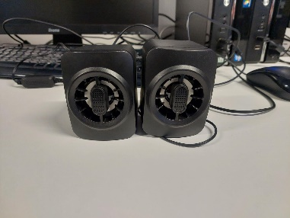
Reiie Pc Speakers: this is the speaker set that we used to play the sound effects and music of the game. This functions fine for the prototype but we could get smaller ones attached to the Computer/Pi if we want to improve the hardware.
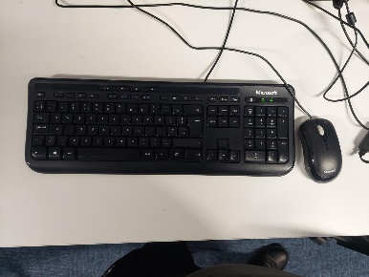
Microsoft Keyboard and Mouse: the keyboard and mouses is the primary input devices for the protype it is necessary for interacting with the Pi and can be used to play the game.
Arcade controls: this is used as an alternative way to control the game, this is not been fully implemented yet as we only received it late into the project but it can be used for the maze part of the game.
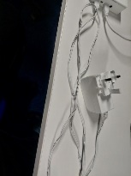
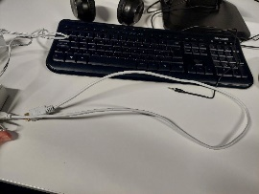
HDMI Cable: this is used to help us to connect the Pi to the monitor and display the programmes running on the Pi.
Power Cable: the power cable is used to supply and manage the current that powers the Raspberry Pi 4.

Task 4 Report - Project Testing
Test Plan
Introduction
The test plan was developed to help us better explain why we were doing each test. As well as plan pout some of the tests we planned to do before caring them out in the test log.
How I Helped
I was responsible for this as well as Archie S and James W I did most of the righting and explanation well James W was responsible for planning and Archie S helped with carrying out the test and some of the test examples.
As explained, I was responsible for writing all of this up and coming up with the examples and objectives.
Details Of the Document and How It Helped Complete the Project.
Test Plan Summary, this was a simple and very small section that was largely just to state what test we were doing and what the primary goal of the test was.
Test Objectives and Descriptions, this was to help define what each type of test was and to clearly explain what our goal was for each type of test.
Testing Examples, this was to show practical examples of the ideas we had we knew we were going to do more than this but the whole team would be responsible for testing the project so we decided that we could not cover all of them in planning and be through. So, we made a few examples instead to show what our plan was in testing and help my team better understand how tests must be done.
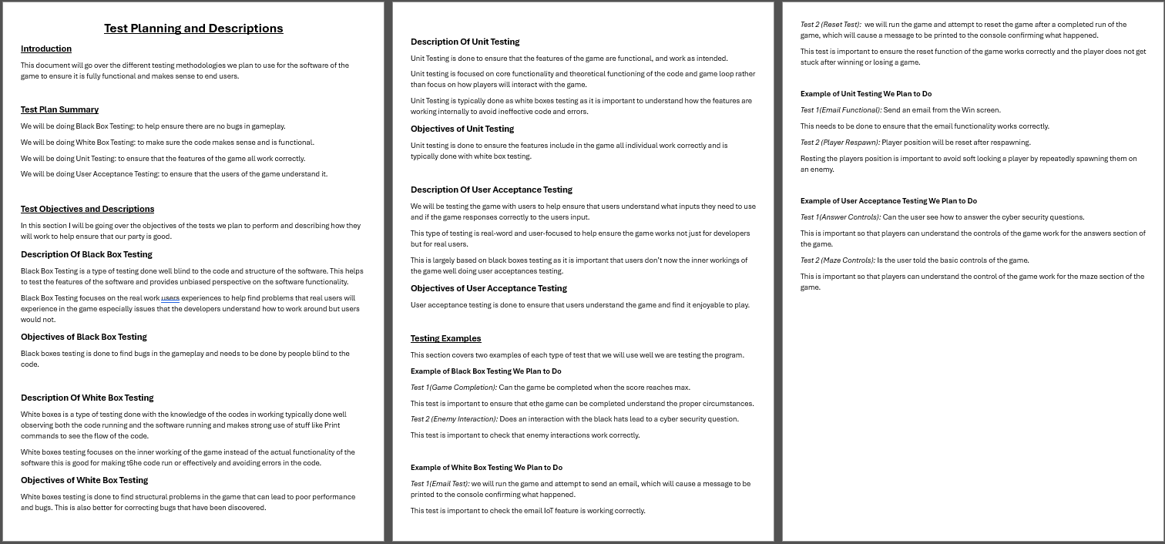

Project Testing
Introduction
This was a critical part of the project development where we tested the viability of the system both for errors and user acceptance. Completing testing was vital to ensuring that the software would be able to meet the standards expected by both stakeholders and End-Users.
How I Helped
I was responsible for the White Box Testing and Unit Testing of the project well Archie S was largely responsible for the Black Box Testing and User Acceptance Testing. The testing was completed in this way to help avoid bias in testing.
Well White Box Testing requires knowledge of the inner workings of the code which I could provide Black Box Testing require somebody with minimal knowledge of the code so Archie S our hardware lead was ideal for this as he had minimal experiences handling the code for the project.
Details Of the Document and How It Helped Complete the Project.
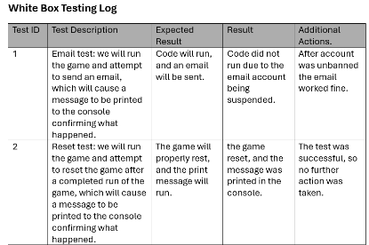
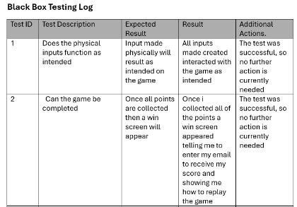
Black Box Testing: the important part of black boxes testing was knowing how the game plays without having knowledge of the code. Because of this we decided that it was best if this was dealt with by Archie S our hardware lead. This approached helps to find bugs the developer of the game may subconsciously work around without realising that’s what they’re doing.
White Box Testing: this is essentially the opposite of the black boxes testing where testing is done incorporating knowledge of the code and ideally the printouts from the IDE to confirm the code is working as you intended it to, and the code is efficient.
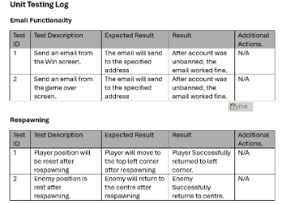
Unit Testing: this is a form of White Boxes Testing that is done to test specific features in the example picture we were testing email functionality and respawning. This can help us to ensure that every part of the game is fully working as we intended and avoid us missing issues more generalised tests would miss.
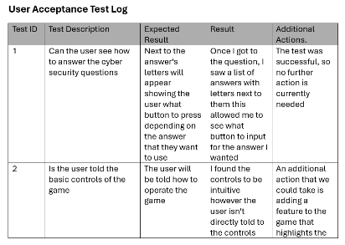
User Acceptance Testing: this is a form of testing not done with the functionality of the software in mind but instead is focused on if the users will be able to understand the games mechanics and User interfaces/experiences. This is essential to ensure that that the game is fit for the needs of end users.

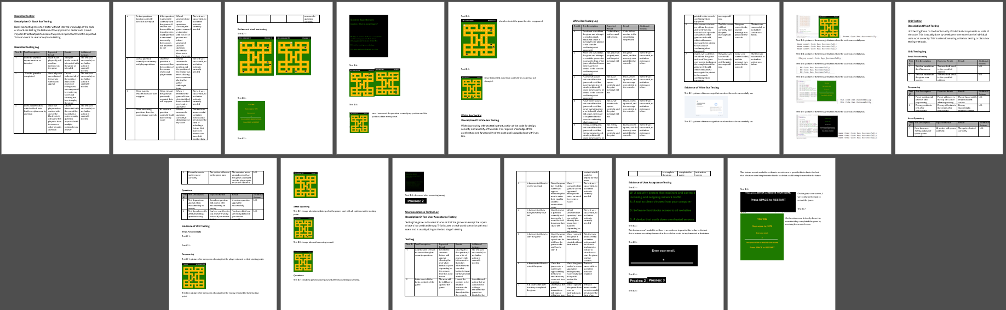

Review of Prototype
Introduction
The review of the protype was a vital step of the post development testing to ensure that the prototype would be fit for the needs of end users and stakeholders and was generally completed to a high standard.
How I Helped
I was responsible for preparing the review form as well as documenting and analysing the results. I felt that it was important to take the lead on the review as the team leader this was my responsibility to coordinate the team during the review and ensure all of the team members opinions where heard.
The entire team myself include was responsible for deciding if the project needed any large overhauls or corrections however our team had decided that we did not needed any large overhauls and small issues where already corrected during development or testing.
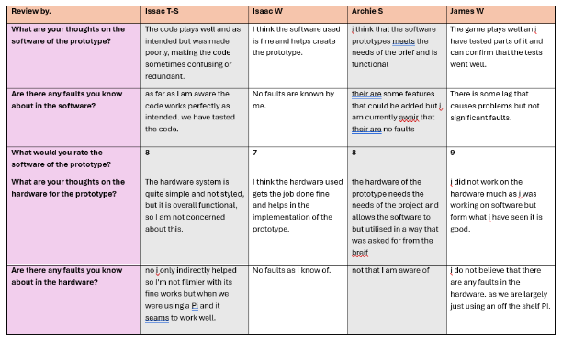
Details Of the Document and How It Helped Complete the Project.
Review Of Prototype: the first section was simple a table contain the results of our review that where originally collected on Microsoft Forms. The review cover if the team where aware of any faults in both the hardware and software, if they felt that the hardware or software need additional, and lastly their overall review of the completed state of the project.
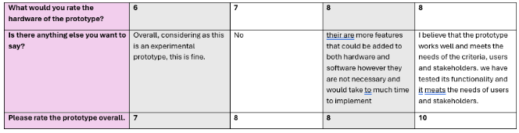
Analysis Of Review of The Porotype: this section covered my analysis of the reviews form everybody though I did ask for the opinions of my teammates well I was making this section and well everybody on the team had their own opinions and ratings of the project nobody was concerned enough about the state of the project to justify any large changes to the project.
Key Features to be Portrayed in the Prototype Checklist: we where given a small list of features that need to be include in the project, so I wanted to make sure that thy were in the project. Most of these where pretty nebulise but so it was especially important that we check and clarify how it was meet. The deferent categories that we were checking for where User Interface Design, System Navigation, Core Functionalities, Integration of Features, and User Interactions, and thankfully we conclude that all of these where included.
Conclusion: this section is simple the finale statement that clarifies what we intended to do. As I have already mentioned we had concluded that the project would sufficiently meet the needs of both the end-users and stakeholders.
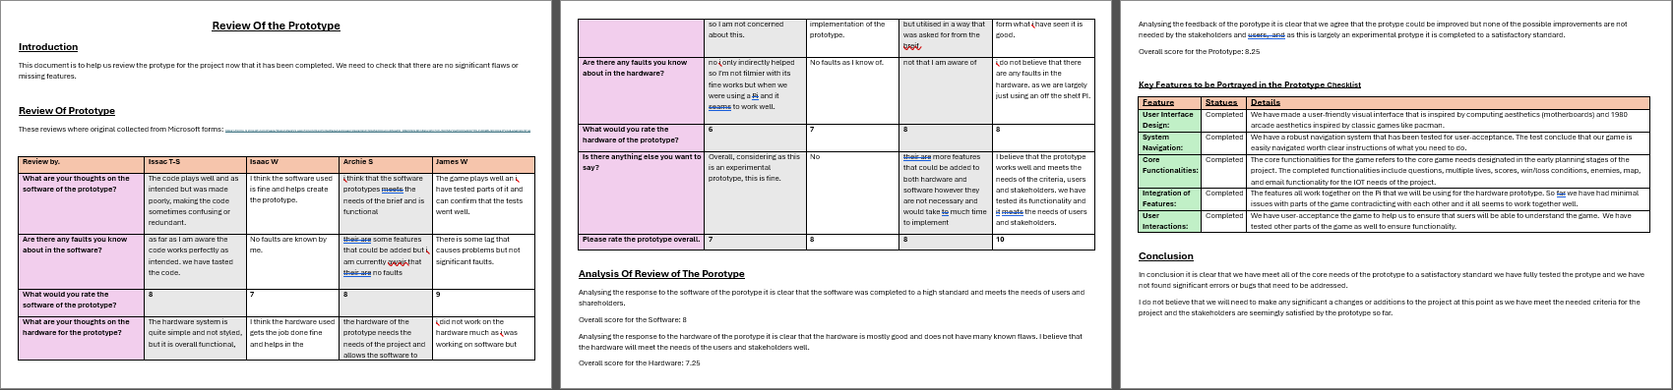

Task 5 Report - Project Operation Review
End Of Project Operational Review and Report
Introduction
This document is the End Of Project Operational Review And Report it purpose as you would have gathered by now is to help us analysis and revisit the project and analyse how I have performed during the project and if the project could overall be considered a success.
I will go down each section of the document and what it covers and to help explain why it is important theses sections are covered.
(All capitalized named for sections that align with parts of this document should by hyperlinked even if they are not in bold or underlined, try CTRL + Click.)

How I Helped
In this section I will not be covering how I helped for each of the documents just what the documents covered and why the report on them is impertinent.
Obviously this document is being done buy me alone as my personal report on the project so everything you see in this document was written by me.

Details Of the Document and How It Helped Complete the Project
Personal Report:
The personal report section was to cover the general aspects of the project such as Team Role, Project Management Methodology, What Went Wrong, and What Went Well. This was to establishes what I was responsible for in the project, how we went about completing the project, and anything I thought went noteworthy well or bad.
Team Role: This section went into the team roles and what I was responsible for the project. This section was to establish that I was responsible for two rather nebulise roles team leader and software development lead, So I had a lot of responsibility through the project and had to ensure a lot of the admin and software side of the project was being due to a high standard.
Project Management Methodology: This section was to cover some of how we managed the project management methodology for the project and to discuss how we decide to use the Scrum PMM. This section was important to establish the basics of the PMM and provide necessary context to the report.
What Went Wrong: This section was important to establish some of the key mistakes of the project that we may be able to learn form in the future. a lot of this basically came down pore communication and our team not being highly skilled but there are still things we learned from working around this through the project.
What Went Well: This section is the opposite of the last one and covered some of the important things in the project that went well. I struggled somewhat with this, but the main thing I focused on in the end was the good teamwork and communication as I felt this really did help to deal with a lot of the issues.

Code Dumps and Comments:
The code dump is a large section that covered around 100 lines of code from the project and fully comment it to help explain how it works. The code selected was in the main game loop that covered movement and asset spawning amongst other key aspects of the maze part of the game. This was important to establish that I understand the code and help others to understand the code.

Task 1 Report - Concept of Operations:
This section covered earliest planning stages and general concept of how we would be operating through the project. This was important to help us establish some of the key principles of the project that would be used throughout all of the work we would be doing.
Project Management Presentation: This document was extremely important to understand our finale choices in Project Management Methodology as it was where we went into the five deferent PMMs we considered to help make the conclusion.
Examination Of Similar IOT Product: This document was to cover some of the research that we did into different projects that were similar to ours. This document helps to show how we went about considering the ways we could ensure our project would be a success.
Feasibility Study and Alternative Feasibility Study: this has an important part of the early stages in the project where we thought about the deferent games we could make and decide upon which was the most viable. Without this our plan would not nearly be as well thought through.

Task 2 Report - Project Design:
This section of the project covered the design for the implementation of our prototype as well as our review of the design and planning to ensure that the project was completed to a high standard. Doing this was important to ensure that we didn’t go into development blind and that our plans for development where well considered.
Implementation Plan: this was the most critical part of task 2 and covered our plan to develop the project and what need to be done to ensure the game would be developed to a high standard. This covered a wide range of tasks that helped us to know what need for development like implementation, testing, and review would be.
Design Review: this covered all prier tasks in task 1 and 2 and was done to ensure that the design and plans where completed to a high standard. This was critical to the project as the planning dedicated the rest of the development and if it was not to the necessary standard, it would impact the rest of the project.

Task 3 Report - Prototype Implementation:
The prototype implementation refers to both the hardware and software development for the project. This is obviously the most critical part of the project as it is essentially the completion of the project though there are still two through tasks dedicated to testing and reviewing the protype to ensure it is completed properly and works as intended.
Software Prototype Development: this was one of the sections I was major responsible for and covered the entirety of the game development which was a vital part of completing the prototype of the project. The creates of the Hack-Man prototype was my responsibility as the software lead of the game so I was the one behind most of the programming of the game.
Hardware Prototype Development: the hardware development was the other half of the development which I was mostly not responsible for as I was not the hardware lead and most helped form the side lines for this part of the project. We mostly keep the hardware basic for the project as we did not have much budget to play with but what we did worked well.

Task 4 Report - Project Testing:
This section of the project covers us ensuring that the protype we had developed worked correctly and was fit for end users and the needs of shareholders. This was critical to us completing the game to the needed standard.
Test Plan: the test plan was made to outline the types of tests that we would be doing explain why we choses theses modes of testing and what they will do. This was important to ensure our test plan was we thought out.
Project Testing: this was our testing log where we did a large verity of testing in the deferent categories set out in the test plan to ensure that the prototype work as intended and was fit for the needs of end users and stakeholders
Review Of Prototype: this was a formal review of the completed prototype done to ensure that the enter team believed that the protype was sufficient and free of all known bugs in the system. This was important to sure that the game was completed correctly and not missing necessary features.

Task 5 Report - Project Operation Review:
This is the review of all the project to help us establish how each part of the project went and how I have performed during the project, as well a giving me the opportunity to show how I have helped to complete the project.
End of Project Operational Review and Report: this is the End of Project Operational Review And Report that is being done to demonstrate what I have done and how I have helped to ensure the project was successful.
End Of Project Future Upscaling Plans: this was done to help us explain how the project could be upscaled and improved in the future and will help us to establish that project was successful and can be continued if needed.

End Of Project Future Upscaling Plans

Recommendation For Future Improvements
Incorporate the Lean PMM: I stand by our choses of Scrum PMM for the start of the project but for the continuation of the project Lean PMM will be better as it is meant for improving projects that our already in production and is especially great at reducing waste which I believe is a key issue in the prototype as it is.
Use Of Project Management Software: for the duration of our project we have only relay used teams for our project well this was fine for us especially considering the skill level of the team at the time, I believe that it may be best for us to use better project management software in the futter similar to Click up as the better features will help us to be compliant with the PMM.
Encourage Seamless Work on the Cloud: most of the work for the project was done in parts independently before being sent to a deferent team member to do a separate part of the document. This technical works ok and was largely best for the time management of the team but is still ineffective and if we could encourage the teams to work better together, we would likely be able to do beater work quicker.
Significant Hardware Overhauls: the hardware of the protype functions but was very much designed with cost in mind and can significantly be improved. We should work to implement a smaller screen and a customer case to better put together the devices with the final goal of a hand heled devices similar to the Gameboy. This could also involve replacing the pi with a custom motherboard and circuitry that are better for the case and devices but devices like would be bast decide upon by the whole team, and especially the hardware lead.
Software Improvements and New Features: as the software lead, I am in the best places to say how we can improve the software, and I would say this comes down to two things structural improvements and new features. The structural improvements would be the inefficiently in the code that can cause issues, especially in the questions section which weas incredibly bad and needs improvement. The new features are optional but would improve the game significantly, the key features I want to add is randomly generated maps as this was something we originally want to do but was abandoned due to it causing bugs in the protype that we did not feel could be fixed in time. Additional IoT features could also be implemented like having it be possible for players to directly compete with each other online which may be fun for players.

How We Could Mass Produces the Prototype
We could kind of mass produces the prototype as it is but it would not be worth doing as the hardware of the prototype is largely an assembly of the shelf parts that we could by and install the software on two to then sell on again, but this would not likely be something people would want to buy. Well, we have completed a competent protype I would not consider it market ready.
We may be able to better mass produce the prototype if recommended improvements have been made as the main issue with the prototype are the hardware which is function but not worth mass producing and if we improved the hardware and made it more efficient to make then it would definitely be worth mass-producing.

Conclusion
This section will help me to sum up this report and by my final conclusion to if the project meets its goals or not.
Was The Project Successful
The original goal as outlined in the scenario was to make a prototype cyber security awareness game to showcase at the Cheltenham Science Festival with internet of things functionality, the game needs to be suitable for ages 8 to 18 and arcade and cyber themed. I will examine theses needs bellow.
Prototype Cyber Security Awareness Game: we have developed both the hardware and software for ethe cyber security awareness game, the game incorporates cyber security questions as part of the enemy encounters and if the player gets the question right, they go free but if they get it wrong they loss a life.
Internet Of Things Functionality: similarly to pacman our game is played in rounds and at the end of each round we have the option to send an email with the score you got to any imputed email address via the internet.
Suitable For Ages 8 To 18: there is no especially violent or otherwise graphic content as well as there not being anything on the gamer that is overly infantilizing so I believe that the game would be enjoyable for people 8, 18 and all ages in between.
Arcade And Cyber Themed: we have themed the game around computers, hacking, and hackers. The maze of the game is designed to look like a motherboard and is gold and green. The enemies and players in the game are based on White Hat Hackers (players) and Black Hat Hackers (enemies). Lives in the game are called proxies and obviously the in-game questions are all cyber security themed.
Overall I feel that I have adequately meet the needs outlined in the scenario for the project and that the game can be considered satisfactory.

Is The Project Upscalable
In the prior section of the document End of Project Future Upscaling Plans I analysed the project to analysis several areas it could be improved like the hardware, new software features, and improving project management. We also analysed if we could mass produces the prototype and conclude that with or without the improvements it would be theoretical mass produced.
Overall, I think it is clear that the project can be upscaled in several ways.

Effective Self-Management
Well, I trust that this document goes to show in a much larger scale the way I have performed throughout the project, in this section I will highlight more specific ways I have been managing myself to ensure professionalism and effectiveness
Evidence Of Management Activities: I was the team leader for the project and have done countless amounts of management activities over the past few months, but I will highly the IoT bored as it is where we communicate tasks as well as the assignment to do list which I mead to help explain them.
The IoT bored had all of the task that I believe we need to do as well as assigning the tasks to the relevant team members thought team members were able to do any task at will if they believed they could.
(Not all of these are actually completed by IT-S but as team leader i was responsible for deciding when the task was done. Strike-ed through tasks are complete)
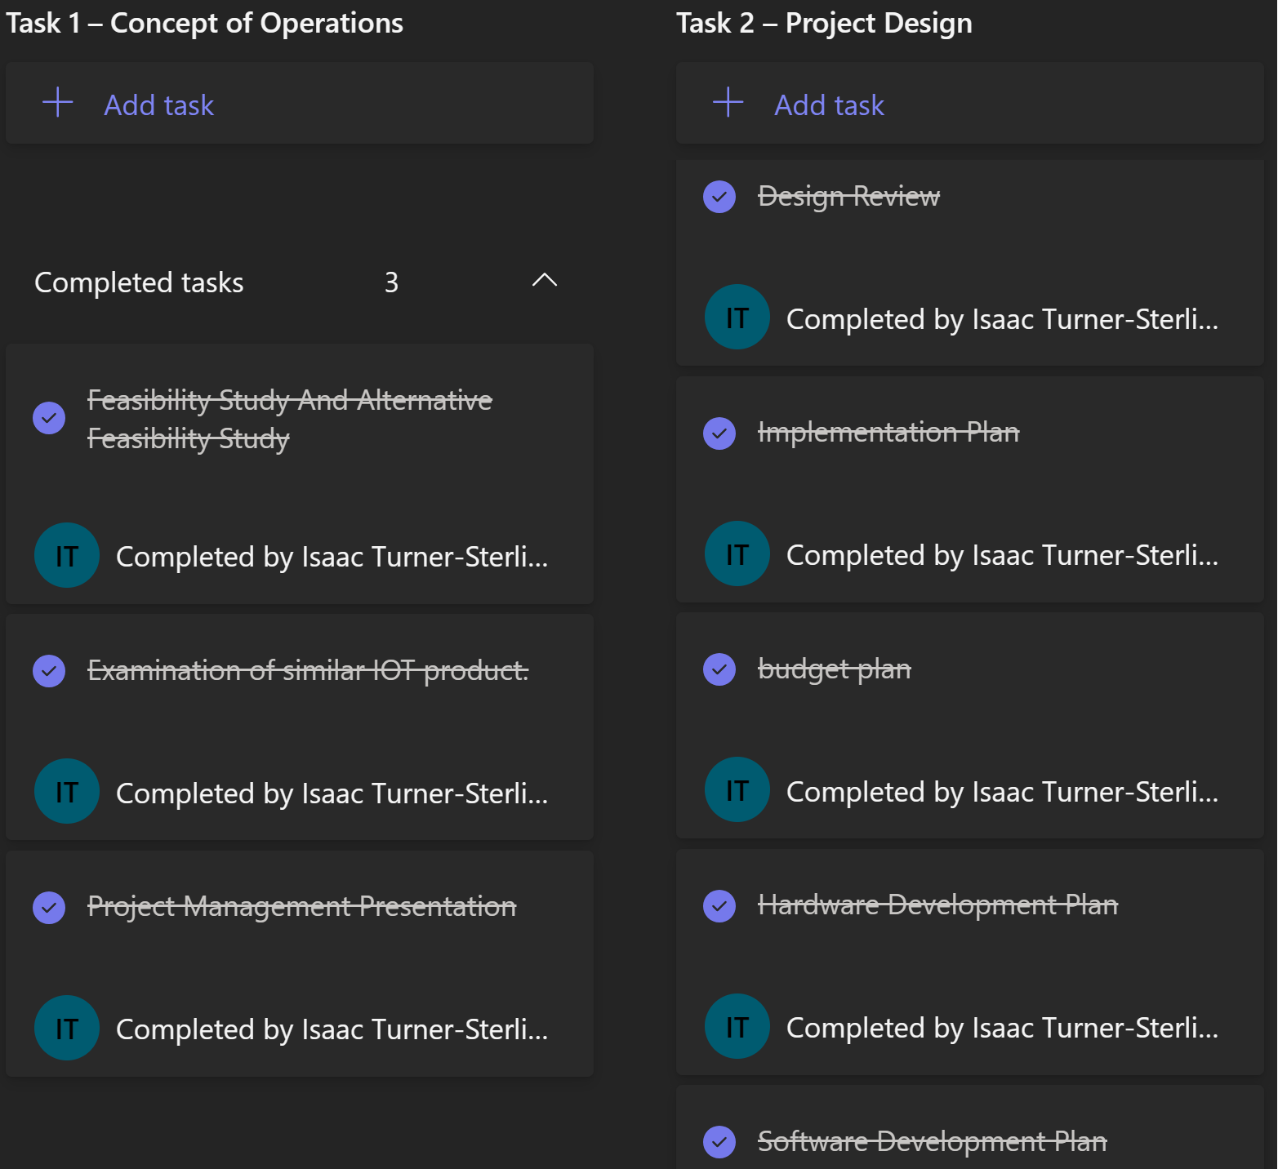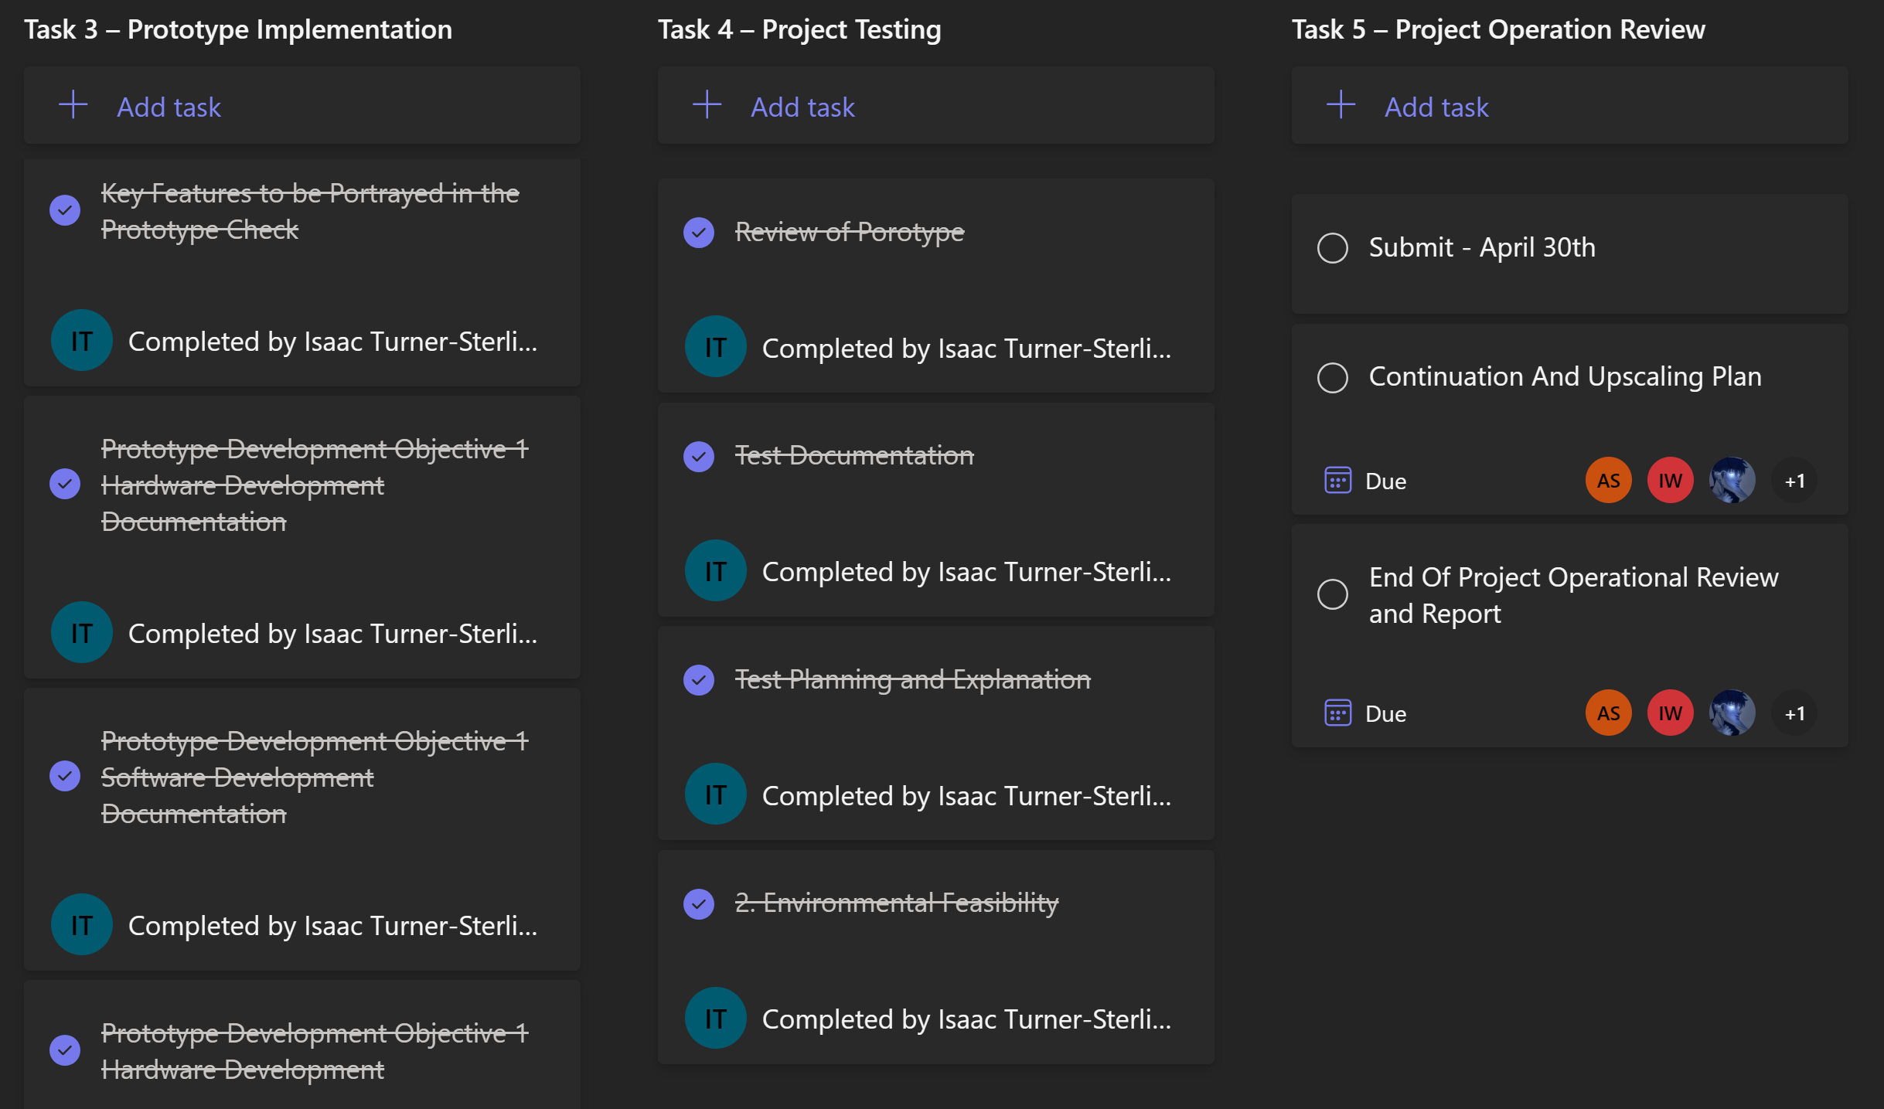
The Assignment Brief to Do List was an edited version of the brief that I made where I reorganised the tasks and criteria to break them down into clear tasks to help my team mates to better understanded what they need to do to properly complete the task with added instructions by me highlighted in blue.
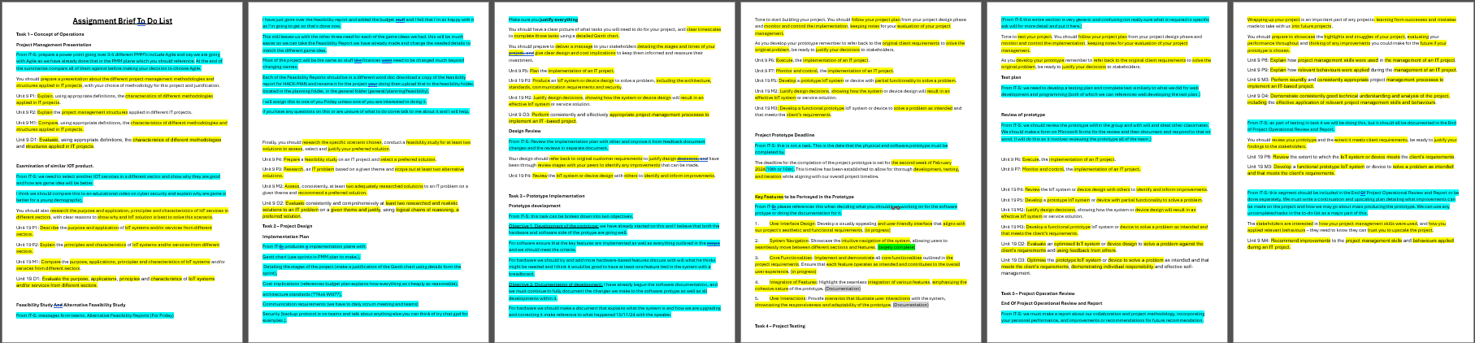
Evidence Of Effective Communication: as this is a team project we have been communicating frequently throughout the project for months, but I will show you some posts I made teams to help guid my team.
this post is a recent post I made covering a new file I made containing four other files containing the deferent tasks work we had done. I made this to help simplify making the personal report and make finding all of the evidence easer for the team as the previous system was a but complicated. In this post I believe it is clear in showing that I was polite and thorough in my communication to help explain for all the team how the new system worked.
The other post is an older example form December that covered a document that Will our teacher wanted us to make and proved some guidance’s and a reference to the team to help them to complete the document in a timely manner as we were out of college that weak, and I was worried they may be confused on what to do.
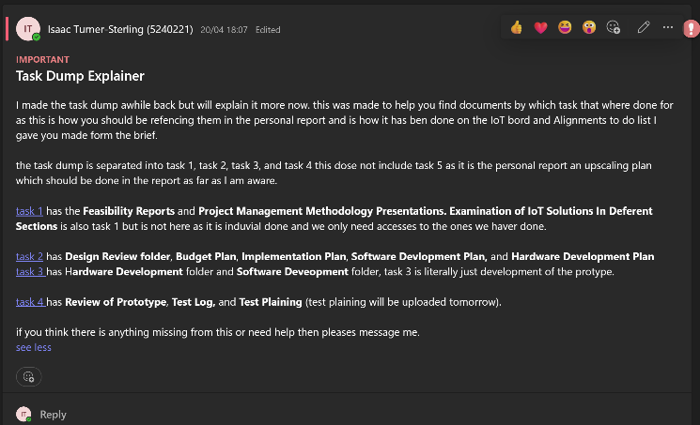
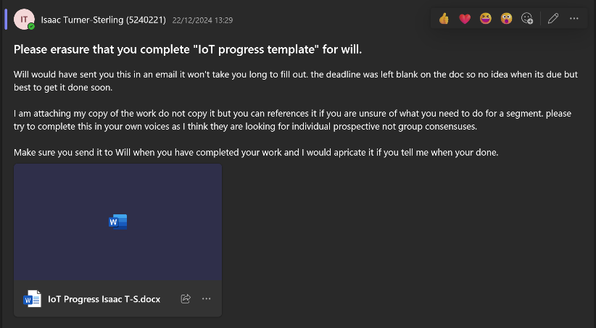
Evidence Of Effective Time-Management: there are a verity of ways we helped to ensure that the project would be completed on time, but I want to focus on Scrum sprints and our personal logs.
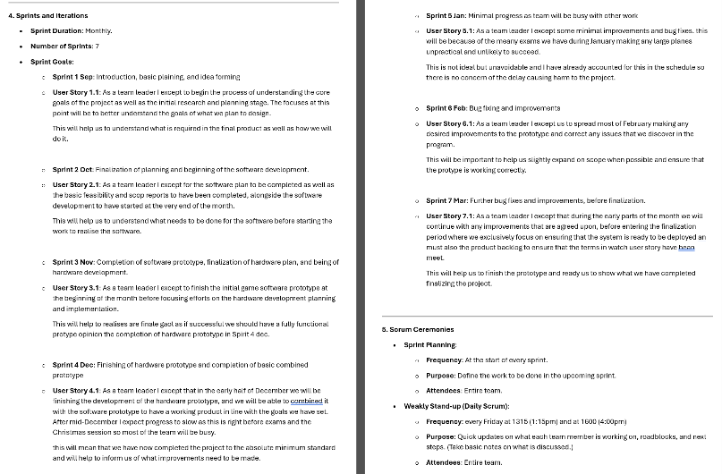
As we used Scrum PMM the inter project was broken down into sprints. To help us complete the project every weak we had Scrum meetings to help us determine the work we need to do and would regularly check our progress with task during the meeting. The screen shot bellow is form an outdated document that covered the original plans for the sprints, but we had to change the plans as time went on and ended up working with weakly sprints instead of monthly though the sprints outlined here are mostly correct to what we were working on we just felt they were both imprecise and unflexible.
During the project I had the teams make a peroneal log that covered what they were doing day to day for the project. This was mostly short, dated sentences that explained or references a task they had worked on or completed. This helped the team, to remember what they were doing day to day and ensure they were being productive.
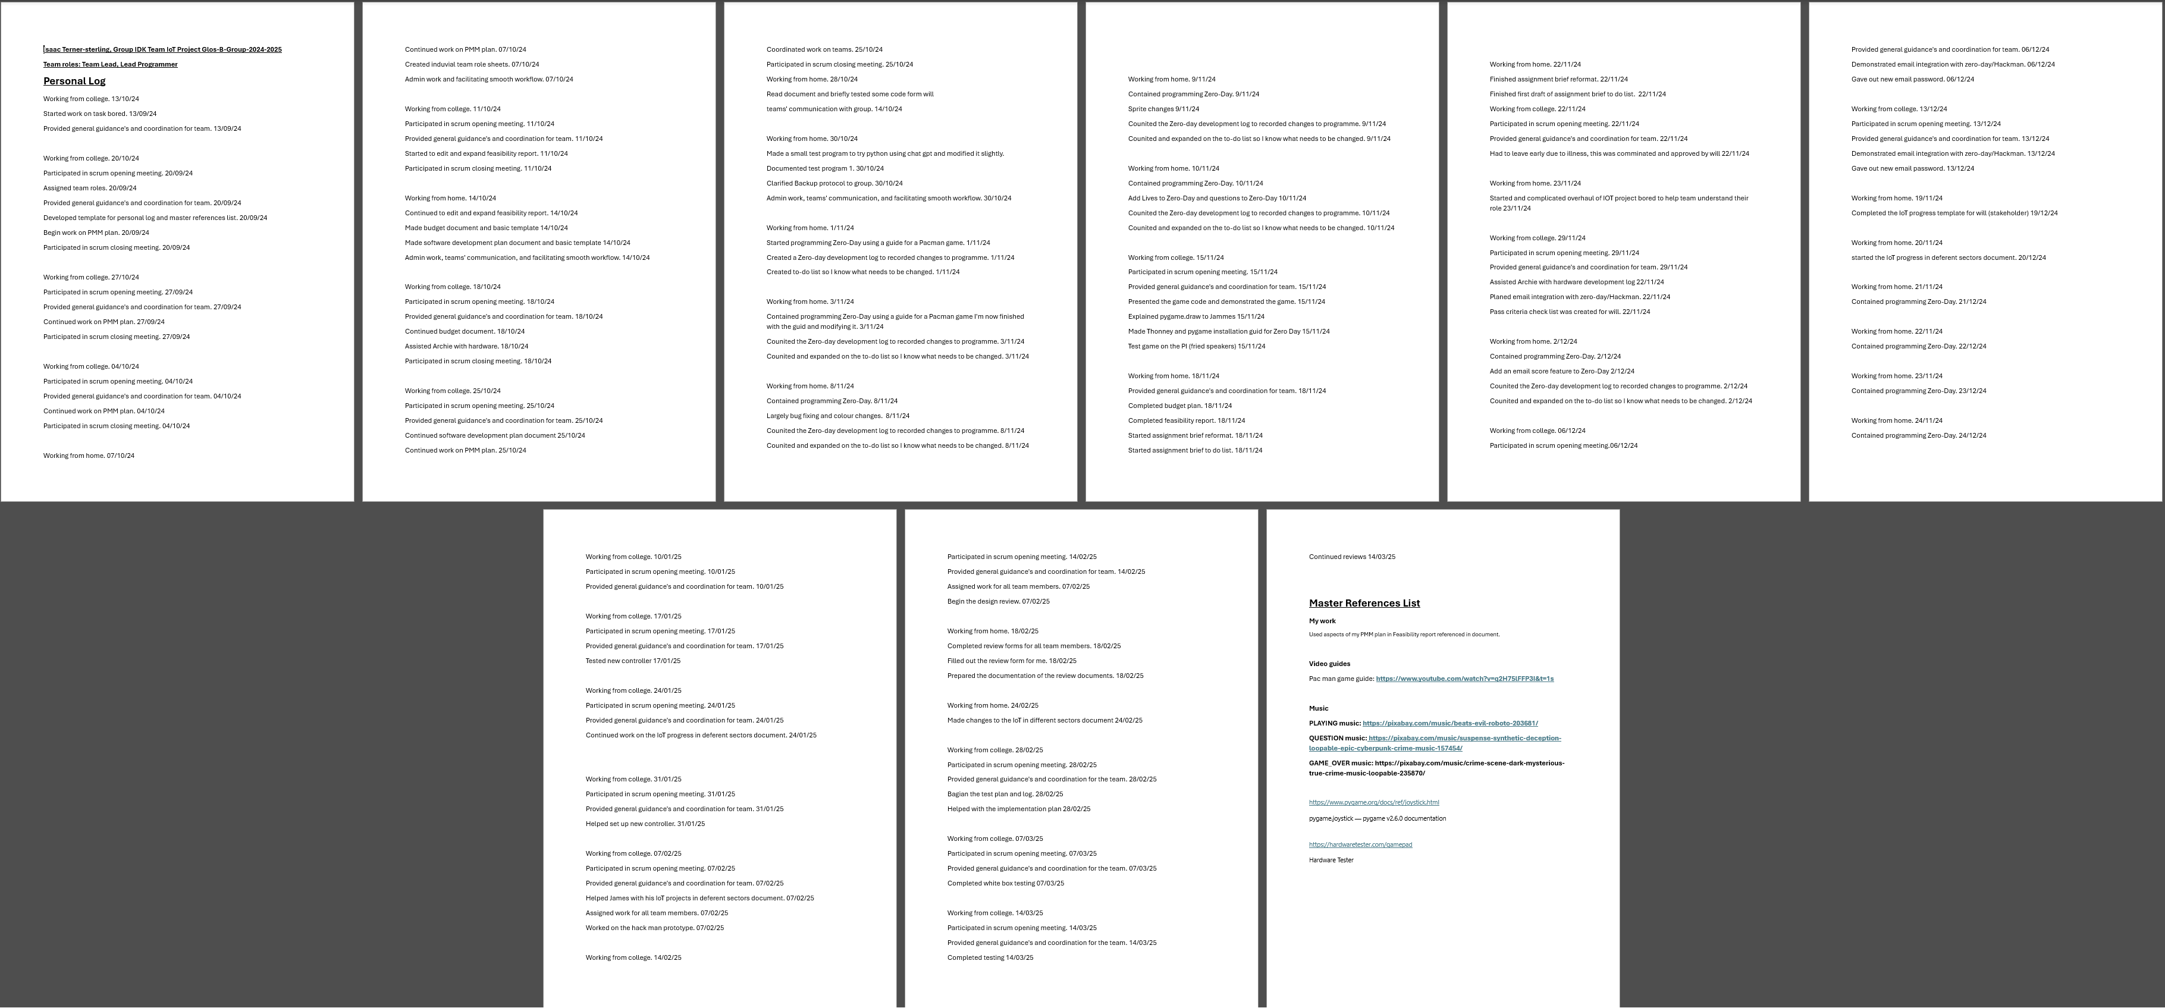

This concludes my report, Isaac Turner-Sterling

